Title (Times New Roman 16, bold, centered)

First author¹, second author²…..(Times New Roman 14, centered, presenting author in bold)

¹ Affiliation (Times New roman 12, centered)
²Affiliation (Times New roman 12, centered)

Text of the abstract (Times New roman 12). References should be cited in the text by numbers [1].
Figures (height ~ 6 cm width ~ 10 cm) and tables can be included within two (maximum) A4 pages in length (cited in the text as Figure 1 or Table 1) and centered according to the following examples:

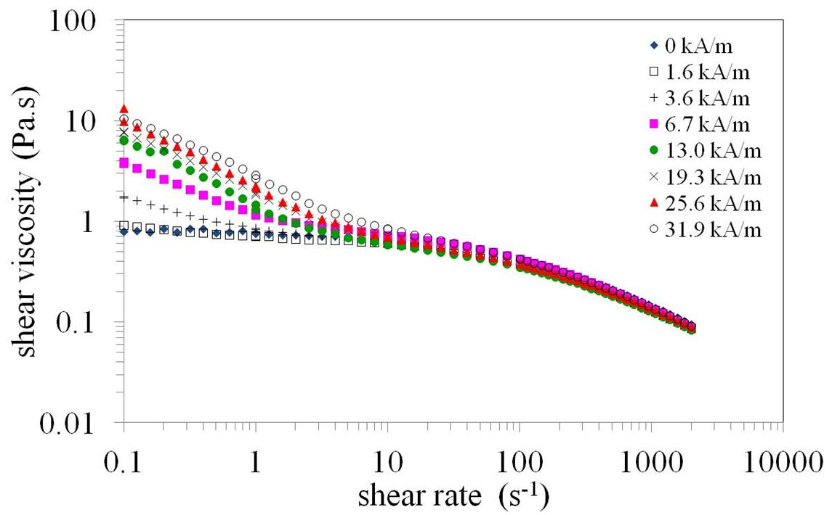
Figure 1: variation of shear viscosity as a function of shear rate

Table 1: caption
Title 1 (unit) | Title 2 (unit) | Title 3 (unit) | Title 4 (unit) | Title 5 (unit)
Value | Value

Example for an article:
[1] D. Ruppert, S.J. Sheather, M.P. Wand, J Am Stat Assoc., 90 (1995) 1257-1270.
Example for a book:
[2] F. Ferraty, P Vieu, “Nonparametric functional data analysis: theory and practice”, Springer-Verlag, (2006).

